<Computational Thinking in P3 Mathematics>
Subject: | Mathematics | Level: | Primary 3
Unit: | 9
Topic: | Money
Summary
Lesson 1: Intro, coding and computational thinking
Lesson 2: Whole Numbers – Multiplication algorithm and mental calculation involving multiplication
Lesson 3: Whole Numbers – Place value in thousands, hundreds, tens and ones
Lesson 4: Whole Numbers - Mental calculation involving addition and subtraction with 2 digit numbers
Lesson 5: Fractions – Visualising equivalent fractions
Lesson 6: Fractions - Expressing fractions in its simplest form
Lesson 7: Geometry – Perpendicular and Parallel Lines
Lesson 8: Geometry – Concepts of angles, right angles, angles greater/smaller than right angles
Lesson 9: Money – Adding and subtracting money in decimal notation.
Lesson 10: Area and Perimeter - Art and Craft work to make a rectangle/square digital wallet with specified dimensions.

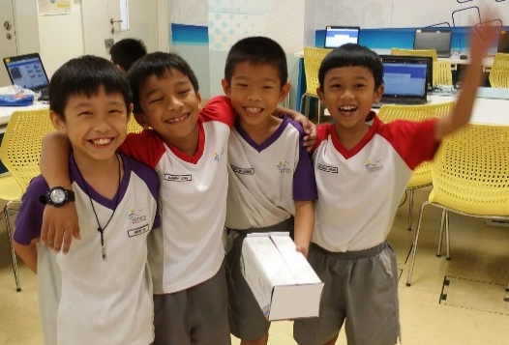
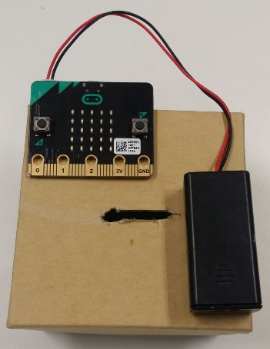
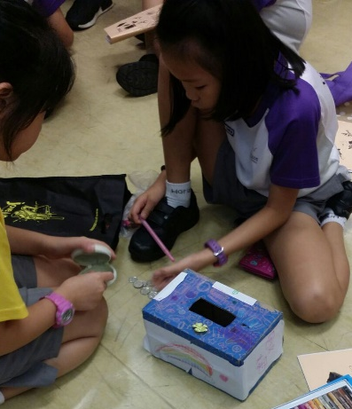

Prior Knowledge: | Students should already know:  1. Counting amount of money in dollars and cents  2. Reading and writing money in decimal notation  3. Converting an amount of money in decimal notation to cents only and vice versa.
Learning Objectives: | By the end of the lesson, students should be able to:  1. add and subtract money  2.  3.

Time | Teacher Activities | Purpose | Resources Needed
Introduction/Pre-activity
5 min | Discuss the value of $1000 (e.g. things that can be bought with a $1000 note)  Use the micro:bit to solve problems in real-world situation, e.g. saving and budgeting.
Lesson development/Main activities
Lesson Development  [ 90 minutes] | Code the programme in micro:bit  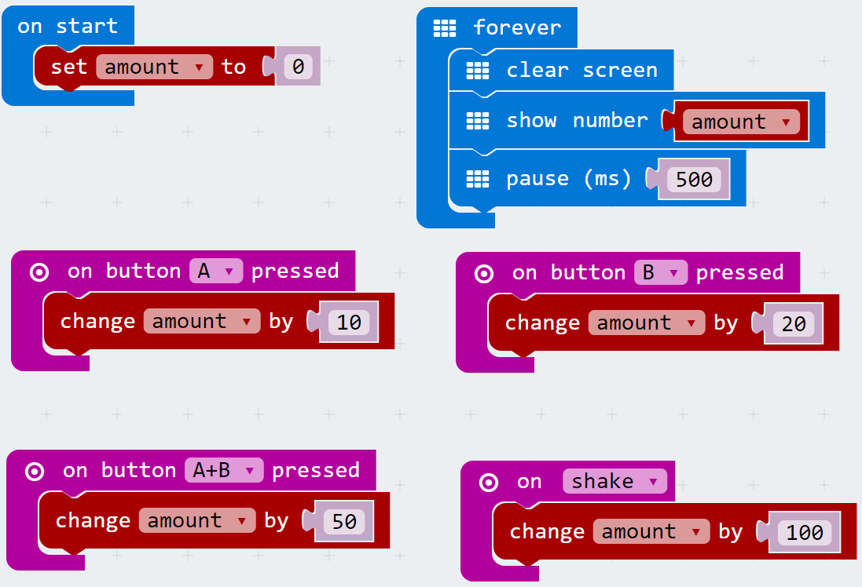  This allows the micro:bit to keep track of the coin bank by acting as a coin counter |  | micro:bit  Makecode coding platform
 | Build the digital coin bank using straws, connectors and recycled materials.  E.g.  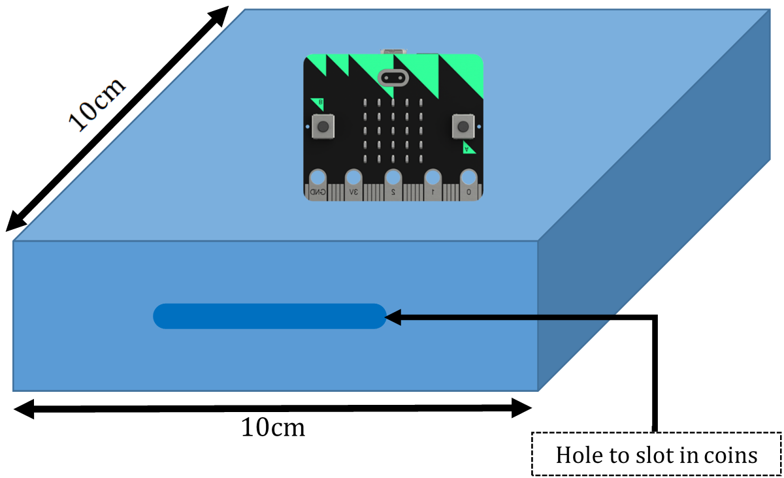 |  | Straws, connectors and recycled materials
Lesson Activity  [20 minutes] | Use the built digital coin bank to work out the following activities. Show the conversion from amount in cents to amount in dollars  E.g.  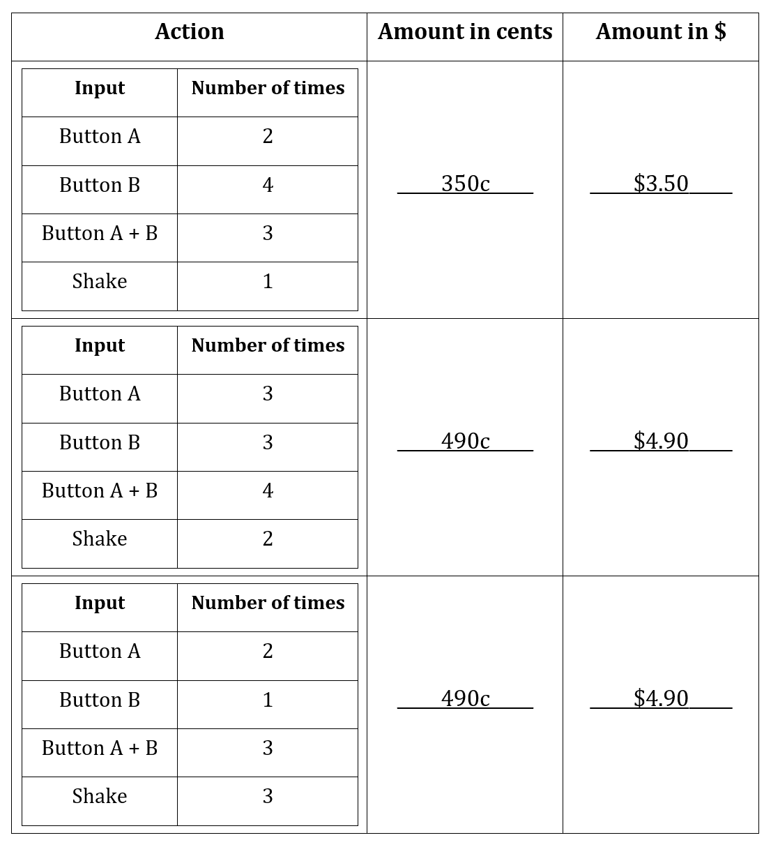
Closure and consolidation/Post-activity
Conclusion  [5 minutes] | Discuss real-world situation, e.g. saving and budgeting.

Please send this template, together with any additional resources, e.g. Powerpoint slides, worksheets and .hex file, to: digital_maker@imda.gov.sg.
Contributed by:

Name of School: Horizon Primary School

Name of Teacher (Optional):

Date: 5 February 2018

