Creating a Micro:Bit Multiplication Calculator
Subject: | Mathematics | Level: | Primary 2
Unit: | Whole Numbers
Topic: | Multiplication of whole numbers
Summary
This lesson is the 6th lesson of an 8 lesson package. The first 5 lessons focus on introducing the Micro:bits and the fundamentals of coding to the Primary 2 students. In this 6th lesson, students will use their knowledge acquired in the previous lessons to code their Micro:bit to work as a Multiplication Calculator.
Lesson 1 – Introduction to Micro:bits
Lesson 2 – Coding Fundamentals : Basic & Inputs
Lesson 3 – Coding Fundamentals : Music & LEDs
Lesson 4 – Coding Fundamentals : Math
Lesson 5 – Coding Fundamentals : Variables
Lesson 6 – Maths Multiplication Calculator Project
Lesson 7 – Completion of Maths Multiplication Calculator Project
Lesson 8 – Parent-Child Micro:bits Engagement Session
In the last lesson, parents are invited to the school for a Parent-Child Micro:bits Engagement Session. Students will guide their parents on how to code a Maths Multiplication Calculator. Parents will then use recycled materials to build a simple prototype.
*Do note that these P2 students have been exposed to block coding with Lego WeDo and Wonder Workshop Dash & Dot.

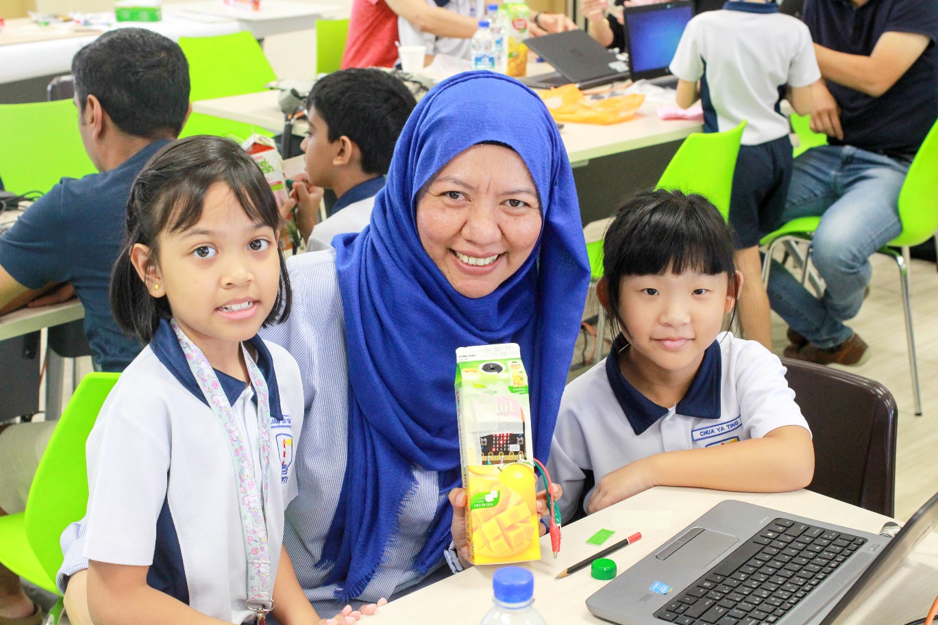

Prior Knowledge: | Students should already know:  1. Multiplication of a whole number by another whole number.  2. Fundamental coding blocks for the Micro:bit.  3. Connection of the Micro:bit to various inputs.
Learning Objectives: | By the end of the lesson, students should be able to:  1. Code the Micro:bit to show and store two variables.  2. Code a button to trigger the two variables to multiply each other.  3. Show the result of the multiplication.  4. Code a button to reset the variables and the answers back to zero.

Time | Teacher Activities | Purpose | Resources Needed
Introduction/Pre-activity
10 mins | T will recap with S on the concept of multiplication of whole numbers.  T will write a few maths multiplication statements on the board,  e.g. 3 x 7 = , 4 x 5 =, 10 x 6 =  and have students write down the answer. T will check with the rest of the class if the answer are correct. | To bring in the students prior knowledge of multiplication and to check on their understanding of the multiplication concept.  Answers will be left on the board for students to check if their micro:bit calculator. | - Whiteboard with marker
Lesson development/Main activities
15 mins | T will show the S a standard calculator and inform them that they will need to use the Micro:bit to code a Multiplication Calculator.  T will discuss with S on some key blocks that they will need think about when the start working on their calculator:  - How will the input the first variable and second variable into their Micro:bit?  - Will each variable to shown?  - How will the variables be stored?  - How will they trigger the Micro:bit to multiply and show the answer?  - How will they reset the Micro:bit to start over again?  T should not provide the answer but allow S to propose suggested ideas.  T will try to get S to come up with different solutions.  T will encourage S to try out their solutions. | Students will be given the opportunity to apply what they have learnt in previous lessons.  Teachers will facilitate the students learning and allow them the opportunity to think through how they should code to solve the problem. | - Calculator/ Calculator app  - Computer with internet access  - Micro:bit set for every student
25 min | S will go the microbit.org to start coding.  T will move around the class and guide S to think about their codes and if it is logical.  T will encourage S to discuss their code with their peers to facilitate collaborative learning.  T will take note of students who have creative ways of coding for discussion during closure and consolidation. | This activity promotes self-directed learning and collaborative learning at the same time.  This technology is engaging and students are motivated to complete projects assigned to them.  At the same time, students are given the opportunity to discuss and work with their peers to improve on their codes. | - Calculator/ Calculator app  - Computer with internet access  - Micro:bit set for every student
Closure and consolidation/Post-activity
10 min | T will ask S to save their files.  T will ask S who have creative ways of coding to present their solution.  When S runs their code, S must explain why the code in a particular manner.  T will refer to the mathematical statements written on the whiteboard to check if they correspond to the correct answer. | When students explain their code, they are able to articulate their thinking. | - Calculator/ Calculator app  - Computer with internet access  - Micro:bit set for every student  - Projector
T will ask students to think of how they can extend their calculator to do
- Division (Intermediate)
- Both Multiplication & Division (Advance)
They will be able to try this during Lesson 7.

Please send this template, together with any additional resources, e.g. Powerpoint slides, worksheets and .hex file, to: digital_maker@imda.gov.sg.

Contributed by:

Name of School: Waterway Primary School

Name of Teacher (Optional): Sim Teck Chuan

Date: 4 Apr 2018

