<Fidget Cube>
Subject: | Music & Art | Level: | e.g. Pri 5
Unit:
Topic: | Creating a fidget cube
Summary
Pupils to make a fidget cube out of the micro:bit and create a unique output for each of the inputs.

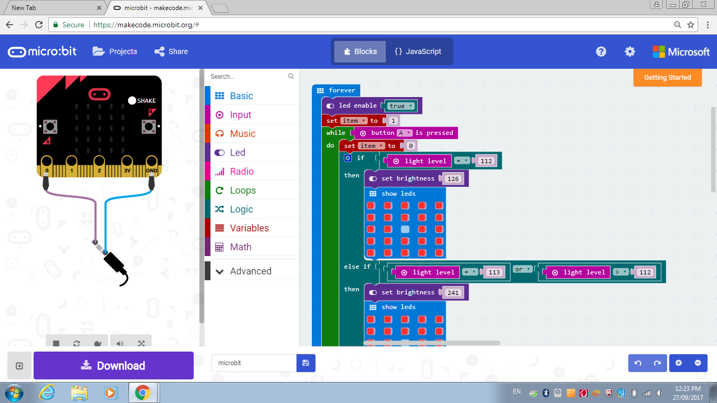

Prior Knowledge: | Students should already know:  1. how to create a unique output for each of the inputs  2. how to program the microbit to be linked to the sound sensor  3. how to program the microbit to be linked to the light sensor
Learning Objectives: | By the end of the lesson, students should be able to:  1. make a fidget cube out of the micro:bit and create a unique output for each of the inputs when the different buttons are pressed.

Time | Teacher Activities | Purpose | Resources Needed
Introduction/Pre-activity
5 minutes | Recap on the steps and coding instructions on using the different sensors with the microbits. | Pupils to have a clearer idea before they start coding their microbit to work like a fidget cube. | Laptop  Microbit  Light sensor  Buzzer
Lesson development/Main activities
15 minutes | Lesson Development – Part 1  - Teacher to engage students using authentic examples related to how they can program the different buttons of the microbit.  - Teacher to brainstorm with the students the different ways of programming the microbit. | Pupils to have a clear idea on how they would like to program the different buttons of the microbit to function like a fidget cube. | Laptop  Microbit  Light sensor  Buzzer
30 minutes | Lesson Development – Part 2  - Teacher gives clear instructions on how the students should code their microbit for this project.  - Students plan their own set of coding instruction for the different buttons on the microbit.  - Students need to program the output for  1) button A  2) button B  3) button A + B  4) on shake  - Students plan and try out on their microbits.  - Teacher walks around the class to facilitate their students’ planning. | Pupils to plan how the fidget cube works with their coding knowledge and skills learnt from the previous lessons. | Laptop  Microbit  Light sensor  Buzzer
25 minutes | Lesson Development – Part 3  - Teacher gives the students materials to build their microbit in it.  - Students use the different materials provided to build the structure for their microbit. | Pupils use their creativity in creating a structure for their fidget cube. | Cardboard  Straws  Tapes  Scissors  Markers
35 minutes | Lesson Development – Part 3  - Students showcase their own coding project – fidget cube to their peers.  - Every student shares their “fidget cube” project. | Pupils share their ideas with their peers so that they can learn more from one another. Pupils also build their confidence level while presenting their project to their friends. | Laptop  Fidget Cube Project
Closure and consolidation/Post-activity
5 minutes | - Teacher wraps up the activity .  - Students return all equipment and materials.

Please send this template, together with any additional resources, e.g. Powerpoint slides, worksheets and .hex file, to: digital_maker@imda.gov.sg.

Contributed by:

Name of School: Pasir Ris Primary School

Name of Teacher (Optional): Tan Mei Yee, Jill

Date: 22 February 2018

