<Throw-Hit Counter>
Subject: | Tech infused PE | Level: | Pri 4
Unit: | Throws and Counting
Topic: | Measuring Throws
Summary
- Use the microbit as a means to count the number of successful throws
- Use the microbit as a self-correcting tool to establish the correct underarm throw

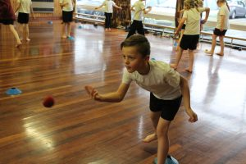

Prior Knowledge: | Students should already know:  1. The basic functions of the microbit  2. Fundamental throwing techniques
Learning Objectives: | By the end of the lesson, students should be able to:  1. Practise and self-correct their throwing techniques  2. Understand and explore possibilities of microbit

Time | Teacher Activities | Purpose | Resources Needed
Introduction/Pre-activity
10 mins | - PE teachers train students on the fundamental skills of the different throws. | Establish the correct method of throwing | Different balls and hoops
Lesson development/Main activities
30 mins | - PE teachers who have been trained to code the micro:bit can use it during the PE lessons in assessing the pupils’ abilities in these skills.  - This can be done through using the contact sensor (when used as a counter to track the number of successful throws, hits) and the directional sensor (when used to show the directional of the attempts of throw and how far the throw is deviated from the target). | Instead of getting peers to count, the counter will indicate the number of successful throws | Microbit counters  Instruction manual
Closure and consolidation/Post-activity
 | - Students with the highest number of successful hits can be asked to demonstrate the correct way of throwing to attain accuracy  - PE teacher highlight to the students the concept behind the counter and challenge students to modify the counter such that it can be used to sense other activity goals. | Allow students to learn from peers.
 | (Optional post-class activity)  Establishing the idea direction using the compass sensor can help students in perfecting their underarm throw |  | Microbit counters

Please send this template, together with any additional resources, e.g. Powerpoint slides, worksheets and .hex file, to: digital_maker@imda.gov.sg.

Contributed by:

Name of School: Sengkang Green Primary School

Name of Teacher (Optional):

Date:10 April 2018

